**15ME304L AUTOMATION LABORATORY**

**TOPIC:**

**MINOR PROJECT REPORT**

**Submitted by**

**Submitted to**

**Mr S. Sampath Kumar M.Tech**

Assistant Professor , Department of Mechanical Engineering, SRMIST.



**Department of Mechanical Engineering**

**SRMIST , Kattankulathur - 603203**

**HYDRAULIC SINGLE ACTUATED SLIDING DOORS**

**INTRODUCTION**

Sliding door is an arrangement of opening and closing mechanism which uses hydraulic actuation using syringe in which pressure is transferred from one syringe to other mechanism.

In this sliding system, hydraulic fluid is used to transmit pressure from one syringe through pipe to the other piston in order to achieve the movement.

**COMPONENTS**

**Wood board**  It is used to provide rigid structure to the door and frame of the wall

**Actuator Arms** It is the connecting Kinematic Arms that can swivel around its ends attached to each other and form a kinematic chain.

**Hard Wires** Thin rods for providing the guide path for the sliding doors and constricting motion of the kinematic chain

**Hydraulic Jacks** Piston actuators for controlling the motion.

**PVC hosepipes** Pipes used the Hydraulic jacks in series and provide the fluid flow for actuation.

**Working Fluid** It is the incompressible liquid used for transmitting force from one actuating piston to other. (Water)

**WORKING**

In the sliding mechanism we use three armatures which moves in a 'Z' shape during actuation.

These armatures are connected by rivets one to other, in which the centre armature (B) is fixed in the centre point. The centre armature can pivot about the centre forming a kinematic chain.

A **kinematic chain** is an assembly of rigid bodies connected by joints to provide constrained motion for the designed model for a mechanical system.

The armature kinematic chain works due to tangential forces acting on each end. The force on one arm (A) acts on the centre arm (B) causing it to pivot about the centre, the rotation causes the third arm (C) to move.

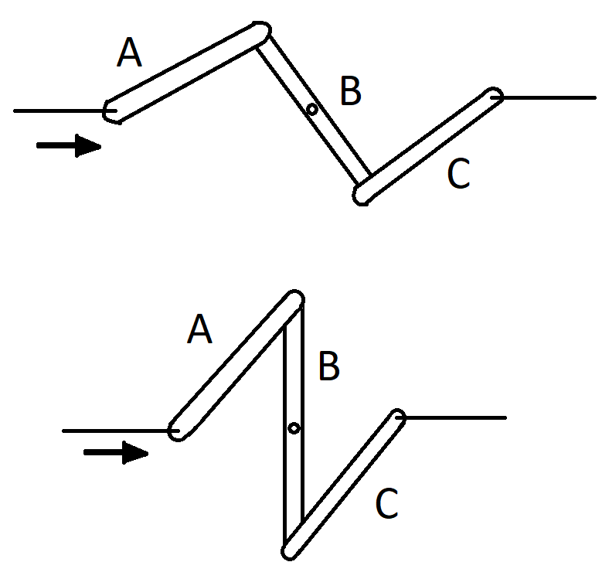

The first(A) and last (C) arm’s free ends are made to slide in a straight line, with each end attached to each slider door. The Door slides on the Hardwire along which the whole actuation moves.

The hydraulic force is made to apply on the free end of one arm (A) from a hydraulic piston or jack which is connected to another hydraulic piston through a PVC hosepipe.

The second jack is used to control the force applied by the first jack causing armature (A) to move setting the kinematic chain motion and therefore causing the door to slide in the direction depending on the direction of hydraulic force applied.

**APPLICATIONS**

* Elevators
* Garage Doors
* Airports
* Veranda Doors
* Windows

**ADVANTAGES**

* The system actuates in a single hydraulic piston force.
* The maintenance cost is less.
* The forces can inverted or modified easily.

**DISADVANTAGES**

* Requires additional space.
* Mechanical efficiency decreases with time.
* Force distribution gets affected by friction, therefore requires regular maintenance.

**RESULT**

Our project on actuating doors with single piston was successfully accomplished